**FINANCIAL DATA ANALYSIS**

**Overview**

This report provides insights into financial data analysis using Power BI, focusing on three core aspects: **DAX functions**, **Hierarchies**, and **Dashboard Views**. The aim is to illustrate how Power BI tools enable efficient analysis and visualization of financial performance, particularly in areas such as sales, profitability, and discounts.

### **DAX Functions**

DAX (Data Analysis Expressions) is a powerful formula language in Power BI used for data modeling and calculations. Below are the main functions applied:

#### ****1. Basic Aggregations****

**Total Sales**  
**Formula:**  
Total Sales = SUM(Sheet1[Sales])  
**Purpose:** Calculates the sum of all sales values in the **Sales**

**Total Profit**  
**Formula:**  
Total Profit = SUM(Sheet1[Profit])  
**Purpose:** Computes the total profit by summing the **Profit**

**Total Discounts**  
**Formula:**  
Total Discounts = SUM(Sheet1[Discount])  
**Purpose:** Adds up all discount values.

#### ****2. Calculated Ratios****

**Profit Margin**  
**Formula:**  
Profit Margin = DIVIDE([Total Profit], [Total Sales], 0)  
**Purpose:** Calculates the ratio of profit to sales

#### ****3. Time Intelligence****

**Year-to-Date Sales (YTD)**  
**Formula:**  
YTD Sales = TOTALYTD([Total Sales], 'Date'[Date])  
**Purpose:** Aggregates sales from the beginning of the year up to the current date.

#### ****4. Advanced Analytics****

**Units Sold by Discount Band**  
**Formula:**  
Units Sold by Discount Band = SUM(Financials[Unit Sold])  
**Purpose:** Sums up units sold based on discount categories.

#### ****5. Filters****

**Sales for a Specific Country**  
Formula:  
Sales for Country = CALCULATE([Total Sales], Financials[Country] = "India")  
Purpose: Calculates sales for transactions where the country is "India."

**High Discount Sales**  
Formula:  
High Discount Sales = CALCULATE([Total Sales], Financials[Discount Band] = "High")  
Purpose: Analyzes sales for transactions with a high discount.

**Sales Category**  
Formula:   
Sales Category = IF( Sheet1[Sales] > 100000, "High", IF(Sheet1[Sales] > 50000, "Medium", "Low") )   
IF( Sheet1[Sales] > 100000, "High", IF(Sheet1[Sales] > 50000, "Medium", "Low") )

**Purpose:** Categorizes sales into "High," "Medium," or "Low."

**Profitability Flag  
Formula:**

Profitability Flag =

IF(Sheet1[Profit] > 0, "Profitable", "Not Profitable")

**Purpose:** Labels transactions as either profitable or not.

**Time of Year**  
Formula:

Time of Year =

SWITCH(

TRUE(),

Sheet1[Month Name] IN {"January", "February", "March"}, "Q1",

Sheet1[Month Name] IN {"April", "May", "June"}, "Q2",

Sheet1[Month Name] IN {"July", "August", "September"}, "Q3",

Sheet1[Month Name] IN {"October", "November", "December"}, "Q4"

)

**Purpose**: Assigns each transaction to a calendar quarter.

**HIERARCHIES**

Hierarchies in Power BI enable structured, drill-down analysis:

**COGS Hierarchy**

COGS → Manufacturing Price → Sale Price

**Product Hierarchy**

Product → Discount Band → Discounts → Unit Sold

**Year Hierarchy**

Year → Date → Month Name → Month Number

### **DASHBOARD VIEWS**

The Power BI dashboard consists of three key sections, providing actionable insights into sales and profitability:

#### ****SALES PERFORMANCE OVERVIEW****

#### 

**KEY METRICS**:

Total Sales: $118.73M

Total Discounts: $9.21M

Total Profit: $16.89M

**VISUALIZATIONS**:

Line charts show monthly sales and profit trends.

Pie and bar charts illustrate segment contributions.

Filters: Year, Segment, Country, Discount Band.

#### ****REGIONAL SALES AND PROFITABILITY****

#### 

**KEY METRICS**:

Sales and profitability analyzed by country and product.

Sales categorized into High, Medium, and Low.

**Filters**: Product, Country, Profitability Flag.

#### ****3. DISCOUNT AND PROFITABILITY INSIGHTS****

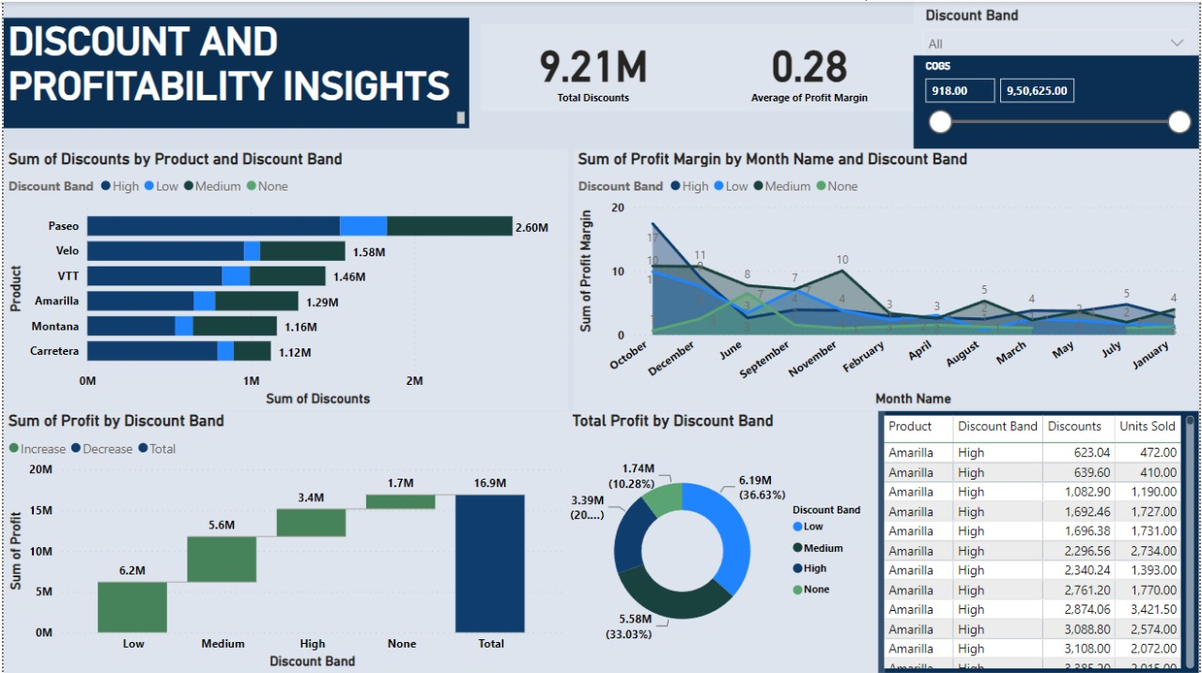

**Key Metrics**:

Discounts analyzed by product and discount band.

Profit margins tracked monthly.

Data tables provide detailed metrics like discounts, units sold, and COGS.

**Filters**: Discount Band, COGS.

### **CONCLUSION**

This report demonstrates how Power BI and DAX functions provide a comprehensive approach to financial data analysis. With a focus on aggregations, calculated measures, and hierarchies, the dashboard facilitates data-driven decision-making to enhance organizational performance.